Resources for YouthBuild Programs
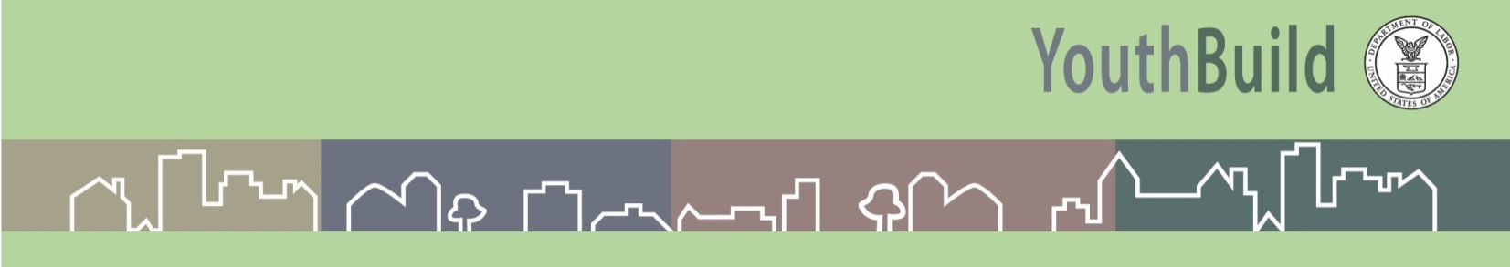

Construction Curricula

Classroom construction training must result in an industry-recognized certification for the young people.

HBI-PACT: the workforce development arm of National Association of Home Builders (NAHB)
- Promotes the home building industry as a career and helps address its workforce needs through programs and resources
- Includes trades training and job placement
- Instructor candidates must have at least 5 years of experience in their trade to qualify for certification
- Certification will expire after 2 years if the Instructor has not submitted for a certificate in that time frame
- HBI requires all YouthBuild programs to sign a licensing agreement in order to deliver the PACT curriculum. Current DOL grantees will pay $75 per certificate for the first 30 submissions and $100 for all certifications after that. Non-DOL YB programs must enter a separate technical assistance contract with HBI in order to deliver certificates.

The National Center for Construction Education and Research (NCCER): is a not-for-profit education foundation
- Created to develop industry-driven standardized craft training programs with portable credentials to help address the critical workforce shortage facing the construction industry.
- Potential Instructors qualifications are to have Journey level experience or to have taught in a vocational training environment for at least 3 years. NCCER offers over 75 craft (trade) areas of certification.

The Building Trades Multi-Craft Core Curriculum, 120-hr curriculum, is created and owned by the Building Trades Department of the AFL-CIO. The training is offered to program coordinators and instructors who are either currently working with or who wish to work with the building trades in their area. This curriculum does not incorporate a hands-on component.
Participants who successfully complete the training will:
- Practice teaching construction concepts using participatory methods
- Develop strategies for delivery of the curriculum in conjunction with local building trades councils.

BPI A national standards development and credentialing organization for residential energy efficiency retrofit work –
- Provides training through a network of training affiliate organizations, individual certifications, company accreditations and quality assurance programs
- An independent, not-for-profit organization
- Brings together leading building science experts from across North America to develop standards using a consensus-based methodology.
- The nation's premier building performance credentialing, quality assurance and standards setting organization.
- Develops technical standards using an open, transparent, consensus-based process built on sound building science.
- Approved by the American National Standards Institute, Inc. (ANSI) as an accredited developer of American National Standards and as a certifying body for personnel credentials. BPI is also approved by the WAP Weatherization Assistance Program under DOE to provide this needed training and education

