Resources for YouthBuild Programs
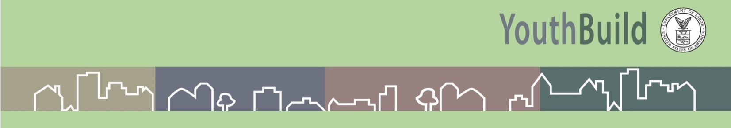

Construction Component
YouthBuild Construction Site Check List

__ Initial Site Inspection
__ Scope of Work/Plans/Specifications
__ Materials List
__ Budget
__ Timeline
__ Purchasing Procedures
__ Materials Delivery Plan
__ Tools and Equipment
__ Permits and Insurance Binders
__ Access to the Site in Writing
__ Safety Plan
__ Security
__ Subcontractors’ Contract
__ Construction Trainers
__ Participant Assignments
__ Transportation
__ Standard Weekly Work Schedule
__ Daily Log Sheet
__ Project Back Up Plan
__ Construction Competency Check list

