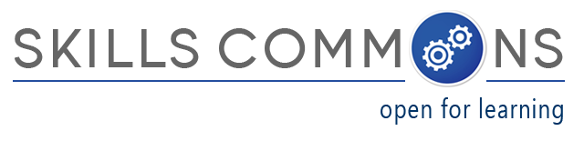

**Showcase for OER Reuse:**

**“Basic Computer Skills Course (BITS)”**

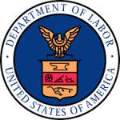The U.S. Department of Labor’s [Trade Adjustment Assistance Community College and Career Training (TAACCCT) grant program](http://www.doleta.gov/taaccct/) has created an online library called SkillsCommons containing free and open learning materials and program support materials for job-driven workforce development.  The Open Educational Resources (OER) are produced by community colleges across the nation and can be found, reused, revised, retained and redistributed by individuals, institutions, and industry.

SkillsCommons.org is designed and managed by the [California State University](http://calstate.edu/) and its [MERLOT program](http://www.merlot.org/merlot/index.htm) for the U.S. Department of Labor’s TAACCCT grant program under a four-year cooperative agreement. If you are interested in the materials, the CSU-MERLOT dedicated team of librarians, educators, and developers are here to assist not only TAACCCT Grantees, but anyone who is using and reusing OER.

Here is an example developed by a TAACCCT Grantee for reuse:

**Project Name:** “Intentional Networks Transforming Effective and Rigorous Facilitation of Assessment, Collaboration, and Education (INTERFACE) (Round 3) <https://www.skillscommons.org/handle/taaccct/246>

**Lead Institution:** Northcentral Technical College District (NTC)

**Project Director:** Kathy Spada, Northcentral Technical College District (NTC)

Ph: 715-803-1747; email: [Spada@ntc.edu](mailto:Spada@ntc.edu)

**Project Goals:** To develop, improve, and expand adult educational training pathways to careers in information technology-related occupations.

**Strategy to Achieve Goals:** A statewide set of core competencies was developed for the computer literacy course. The competencies were established during a stakeholder meeting in April 2014. In addition to the 16 WTCS college representatives, WTCS system administrators, INTERFACE project administration, and workforce partners were also present at the competency planning meeting and contributed to the development of course competencies. The meeting was facilitated by a representative of the Worldwide Instructional Design System (WIDS). In total, the meeting resulted in the establishment of 11 core competencies for the basic computer skills for college success course.

**Population Served:** This course is designed for Trade Adjustment Act-eligible dislocated workers, Veterans and other adult learners. It can be used by learning centers, job centers and other workforce partners, Wisconsin Technical College System colleges and anyone anywhere with internet access.

**Areas Served:** State of Wisconsin: all cities and counties

**OER for reuse:** A copy of the Basic Computer Skills Course (code name BITS) may be accessed and downloaded by clicking this link: <https://www.skillscommons.org/handle/taaccct/6799>

This course provides information technology literacy and basic skills training for learners with limited experience. Course learning outcomes focus on skill development related to basic computer operations and information technology. An “offline” version of the Basic Computer Skills Course is available for use in locations with limited or no internet access. Please be aware that the course will not track student progress when used offline. We recommend creating a desktop shortcut to the Launch.html file if the course is used without internet. The course will then run automatically in whatever web browser is configured as primary on each computer.

**Benefits of reuse:** After completing the full course, learners will be better prepared to operate computing devices, navigate operating systems, input data, create documents, use email, manage files, use the Internet and social media, safely manage personal data, navigate learning management systems and use college information systems. The Technical College System of Georgia recently discovered the course on [www.wisc-online.org](http://www.wisc-online.org). They will be updating and modifying the modules to fit their needs. Since January 2016, BITS has received over 6,500 views in the USA; it has also been viewed in over 30 countries.

Wisc-online is a repository of high-quality educational learning materials developed by subject matter experts from the Wisconsin Technical College System and Fox Valley Technical College's Learning Innovations team, and available at no cost to learners and educators.

Performance standards and competencies were developed and approved with input from all 16 Wisconsin technical colleges and workforce development partners.