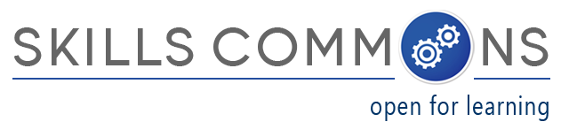
Showcase of OER “Derivative” Reuse:
“Marketing Outreach Plan”

The U.S. Department of Labor’s Trade Adjustment Assistance Community College and Career Training (TAACCCT) grant program has created an online library called SkillsCommons containing free and open learning materials and program support materials for job-driven workforce development. The Open Educational Resources (OER) are produced by community colleges across the nation and can be found, reused, revised, retained and redistributed by individuals, institutions, and industry.

SkillsCommons.org is designed and managed by the California State University and its MERLOT program for the U.S. Department of Labor’s TAACCCT grant program under a four-year cooperative agreement. If you are interested in the materials, the CSU-MERLOT dedicated team of librarians, educators, and developers are here to assist not only TAACCCT Grantees, but anyone who is using and reusing OER.

Here is an example of OER reuse by a TAACCCT Grantee:

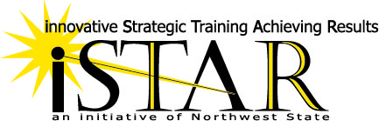
Project Name: Industrial Automation Manufacturing innovative Strategic Training Achieving Results (I AM iStar) (Round 4) https://www.skillscommons.org/handle/taaccct/1442

Lead Institution: Northwest State Community College

Project Director: Sarah Stubblefield, Northwest State Community College
Ph: 419-267-1512; email: sestubblefield@northweststate.edu

Project Goals: To develop a program focused on industrial automation training and designed based on the needs of local employers. The program will offer industry recognized certificates and associate degrees that lead to high-wage, high-skill employment.

Strategy to Achieve Goals: A process for evaluating Prior Learning and a hybrid instructional delivery model will be developed focused on Advanced Manufacturing programs shortening the time to completion of industry recognized credentials, certificate(s), or degree(s). The National Association of Manufacturing (NAM) endorsed certifications will be embedded into the curriculum based on employer input.

Population Served: TAA-eligible workers, long-term unemployed, and other dislocated workers.

Areas Served: Defiance, Fulton, Henry, Lucas, Paulding, Van Wert and Williams counties in Ohio

OER reused: The OER reused was a program management resource from Health Professions Pathways Consortium (H2P) a Round 1 Grant:

“TAA Outreach and Recruitment”: https://www.skillscommons.org/handle/taaccct/2812

Derivative OER created:
“Marketing Outreach Plan”: https://www.skillscommons.org/handle/taaccct/8921

Benefits of reuse: The I AM iStar project was able to save time and money by using this material as part of their grant management strategy.

